Assignment 1
Title: Write Data to CSV File
Problem Statement: Write student details (id, name, marks) into a CSV file named students.csv.
Expected Outcome: CSV file should be created and data should be stored correctly.
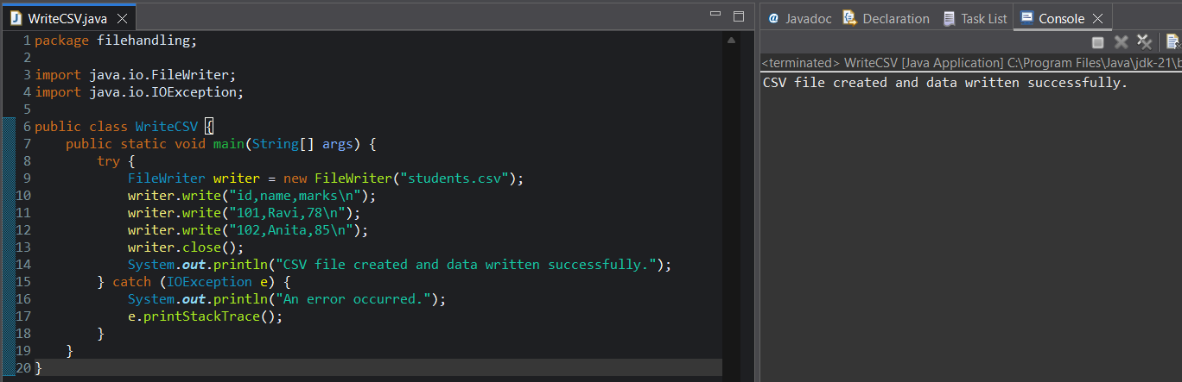
Assignment 2
Title: Read CSV File and Display Data
Problem Statement: Read all records from students.csv and display them on the console.
Expected Outcome: All rows should be printed.
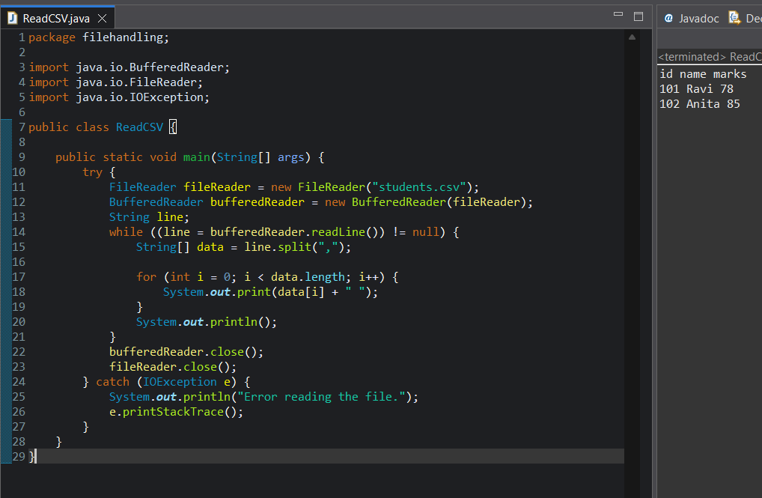

Assignment 3
Title: Display Students with Marks Greater Than 60
Problem Statement: Read students.csv and display only students whose marks are greater than 60.
Expected Outcome: Only eligible students should be printed.
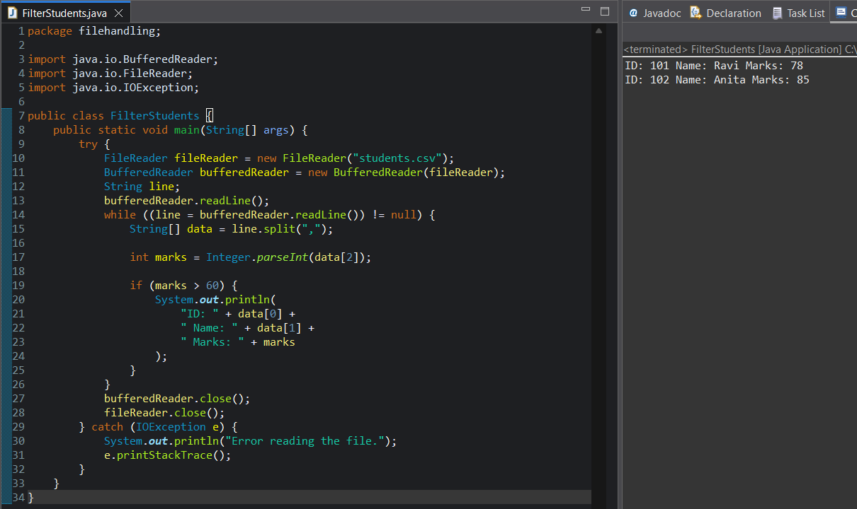
Assignment 4
Title: Count Number of Records in CSV File
Problem Statement: Count how many student records are present in students.csv.
Expected Outcome: Total number of students displayed.
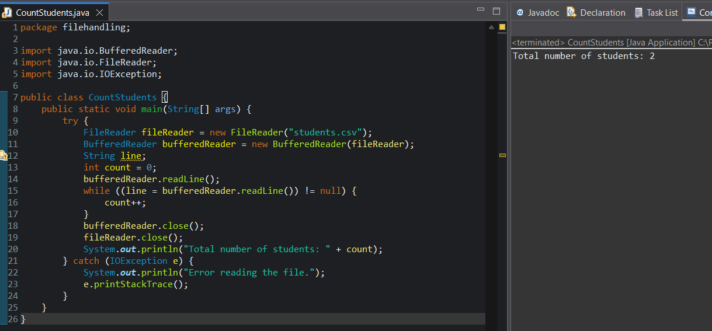

Assignment 5
Title: Search Student by Name
Problem Statement: Search a student by name from students.csv.
Expected Outcome: Matching student details printed.
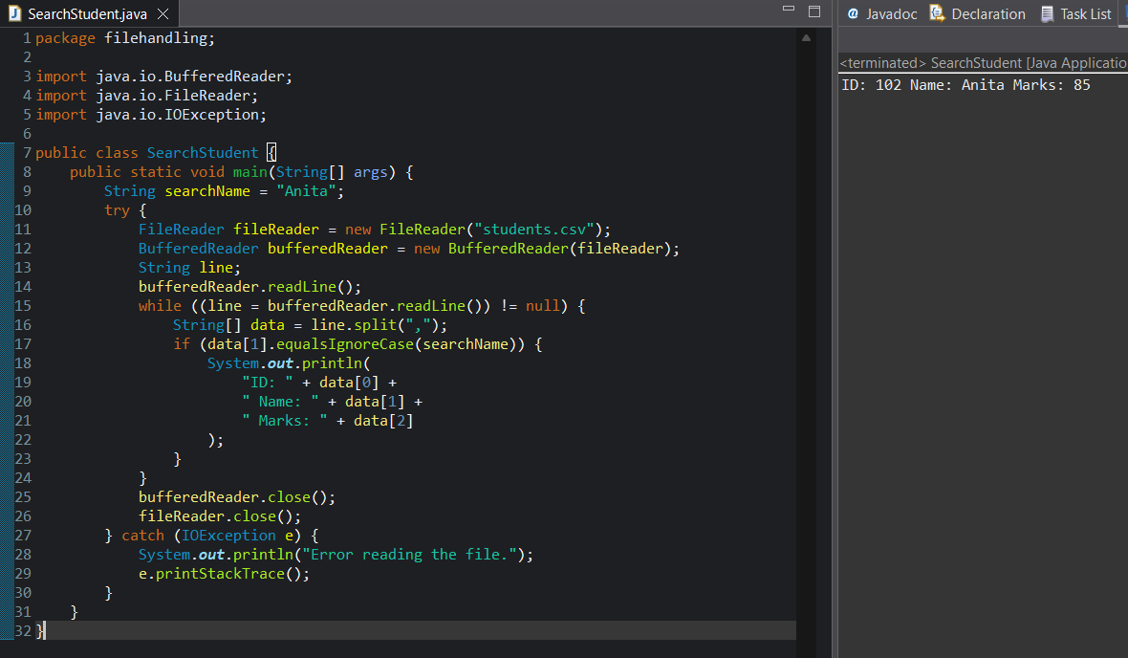
Assignment 6
Title: Display Students Who Failed
Problem Statement: Display students whose marks are less than 40.
Expected Outcome: Only failed students printed.
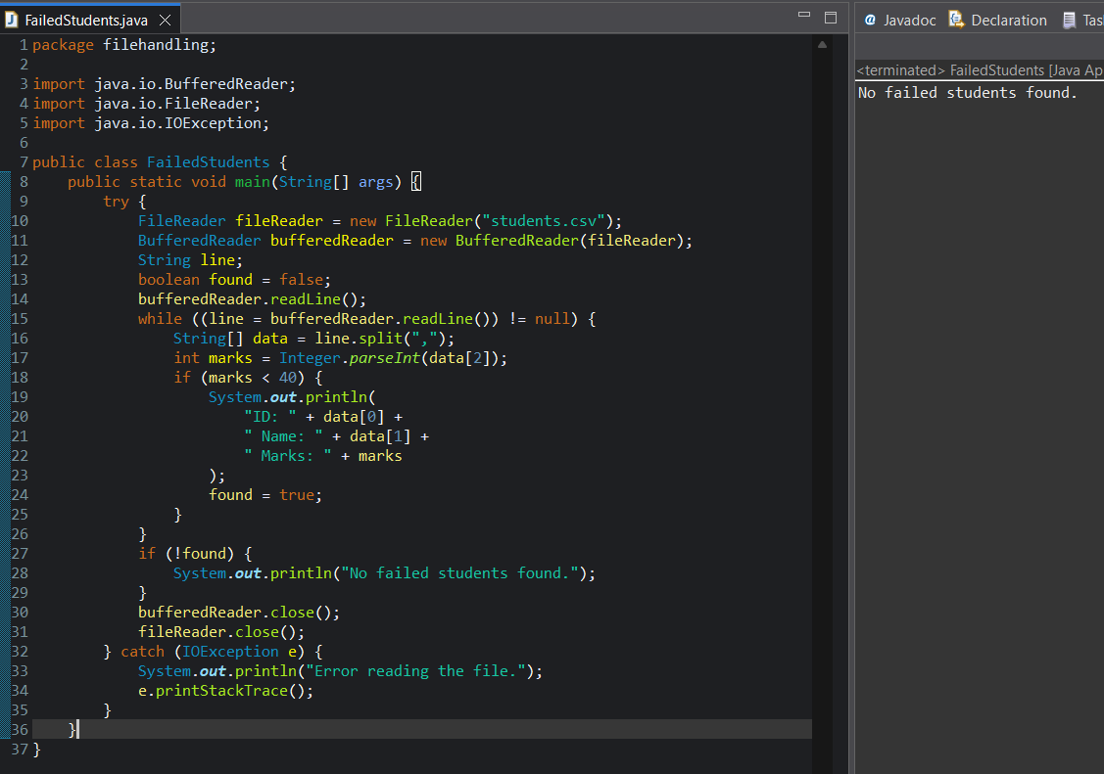
Assignment 7
Title: Calculate Average Marks
Problem Statement: Read marks from students.csv and calculate average marks.
Expected Outcome: Average marks displayed.
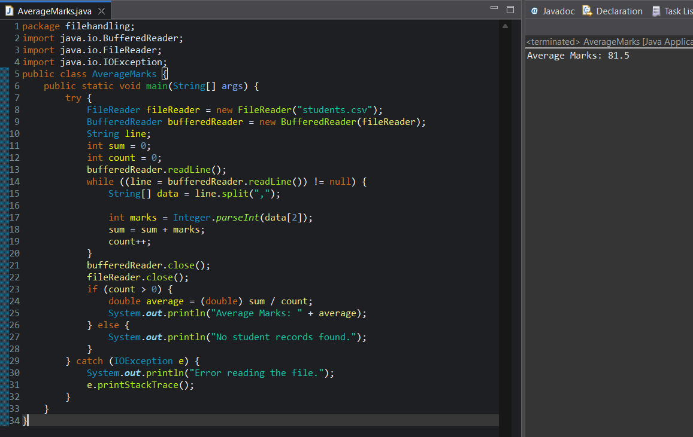
Assignment 8
Title: Copy Passed Students to New CSV File
Problem Statement: Read students.csv and write students with marks ≥ 50 into passed_students.csv.
Expected Outcome: New CSV file created with passed students only.
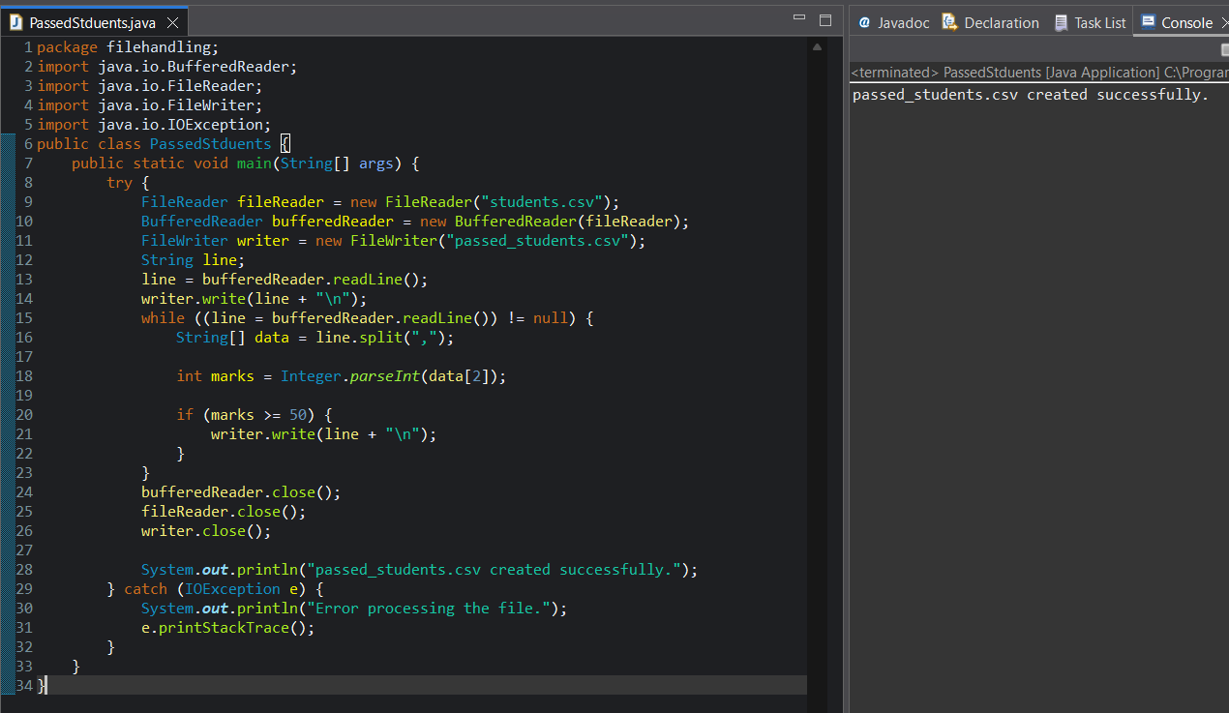
Assignment 9
Title: Validate CSV Data While Reading
Problem Statement: Skip records where marks field is empty or invalid.
Expected Outcome: Only valid records processed.
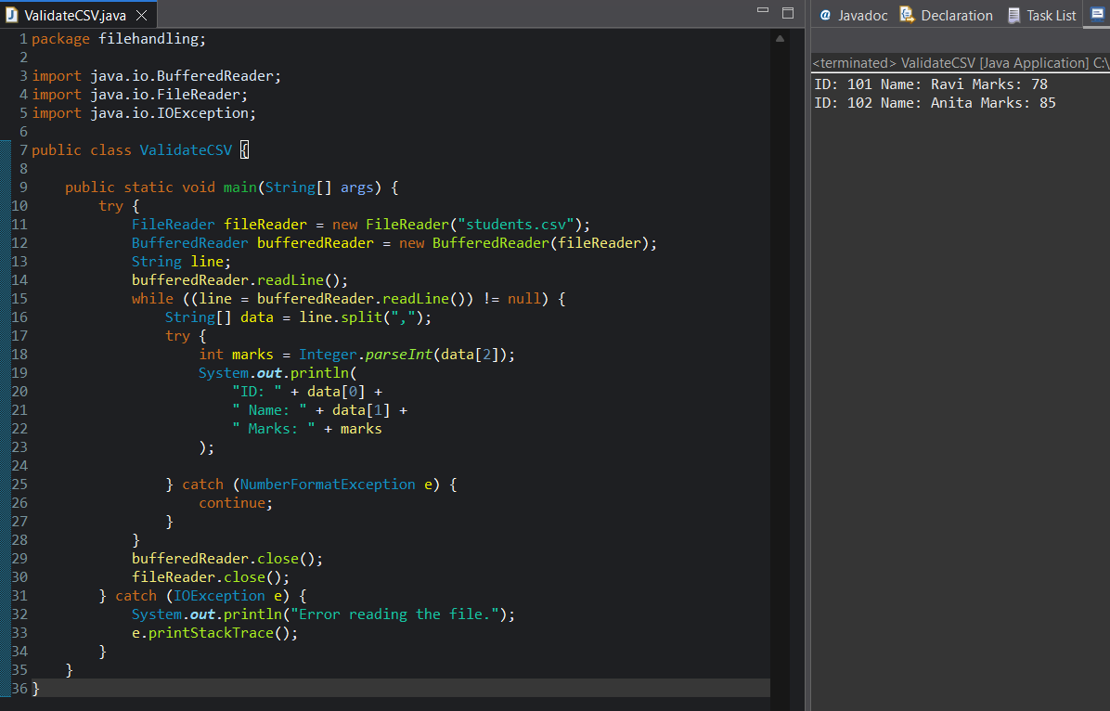
Assignment 10
Title: Display Topper Details
Problem Statement: Find and display the student with highest marks from students.csv.
Expected Outcome: Topper name and marks printed.
